BIOLOGY DEPT
NAMUNGOONA SALAF SEC .SCHOOOL
NUTRITION IN ANIMALS, O9TH JUNE 2020

1.An investigation was carried out to determine the rate at which contents of the stomach are emptied or moved into the duodenum depending on the type of food
An individual was made to drink sucrose solution and also took sme pieces of meat at the same time. The results of the investigation were show on the graph below
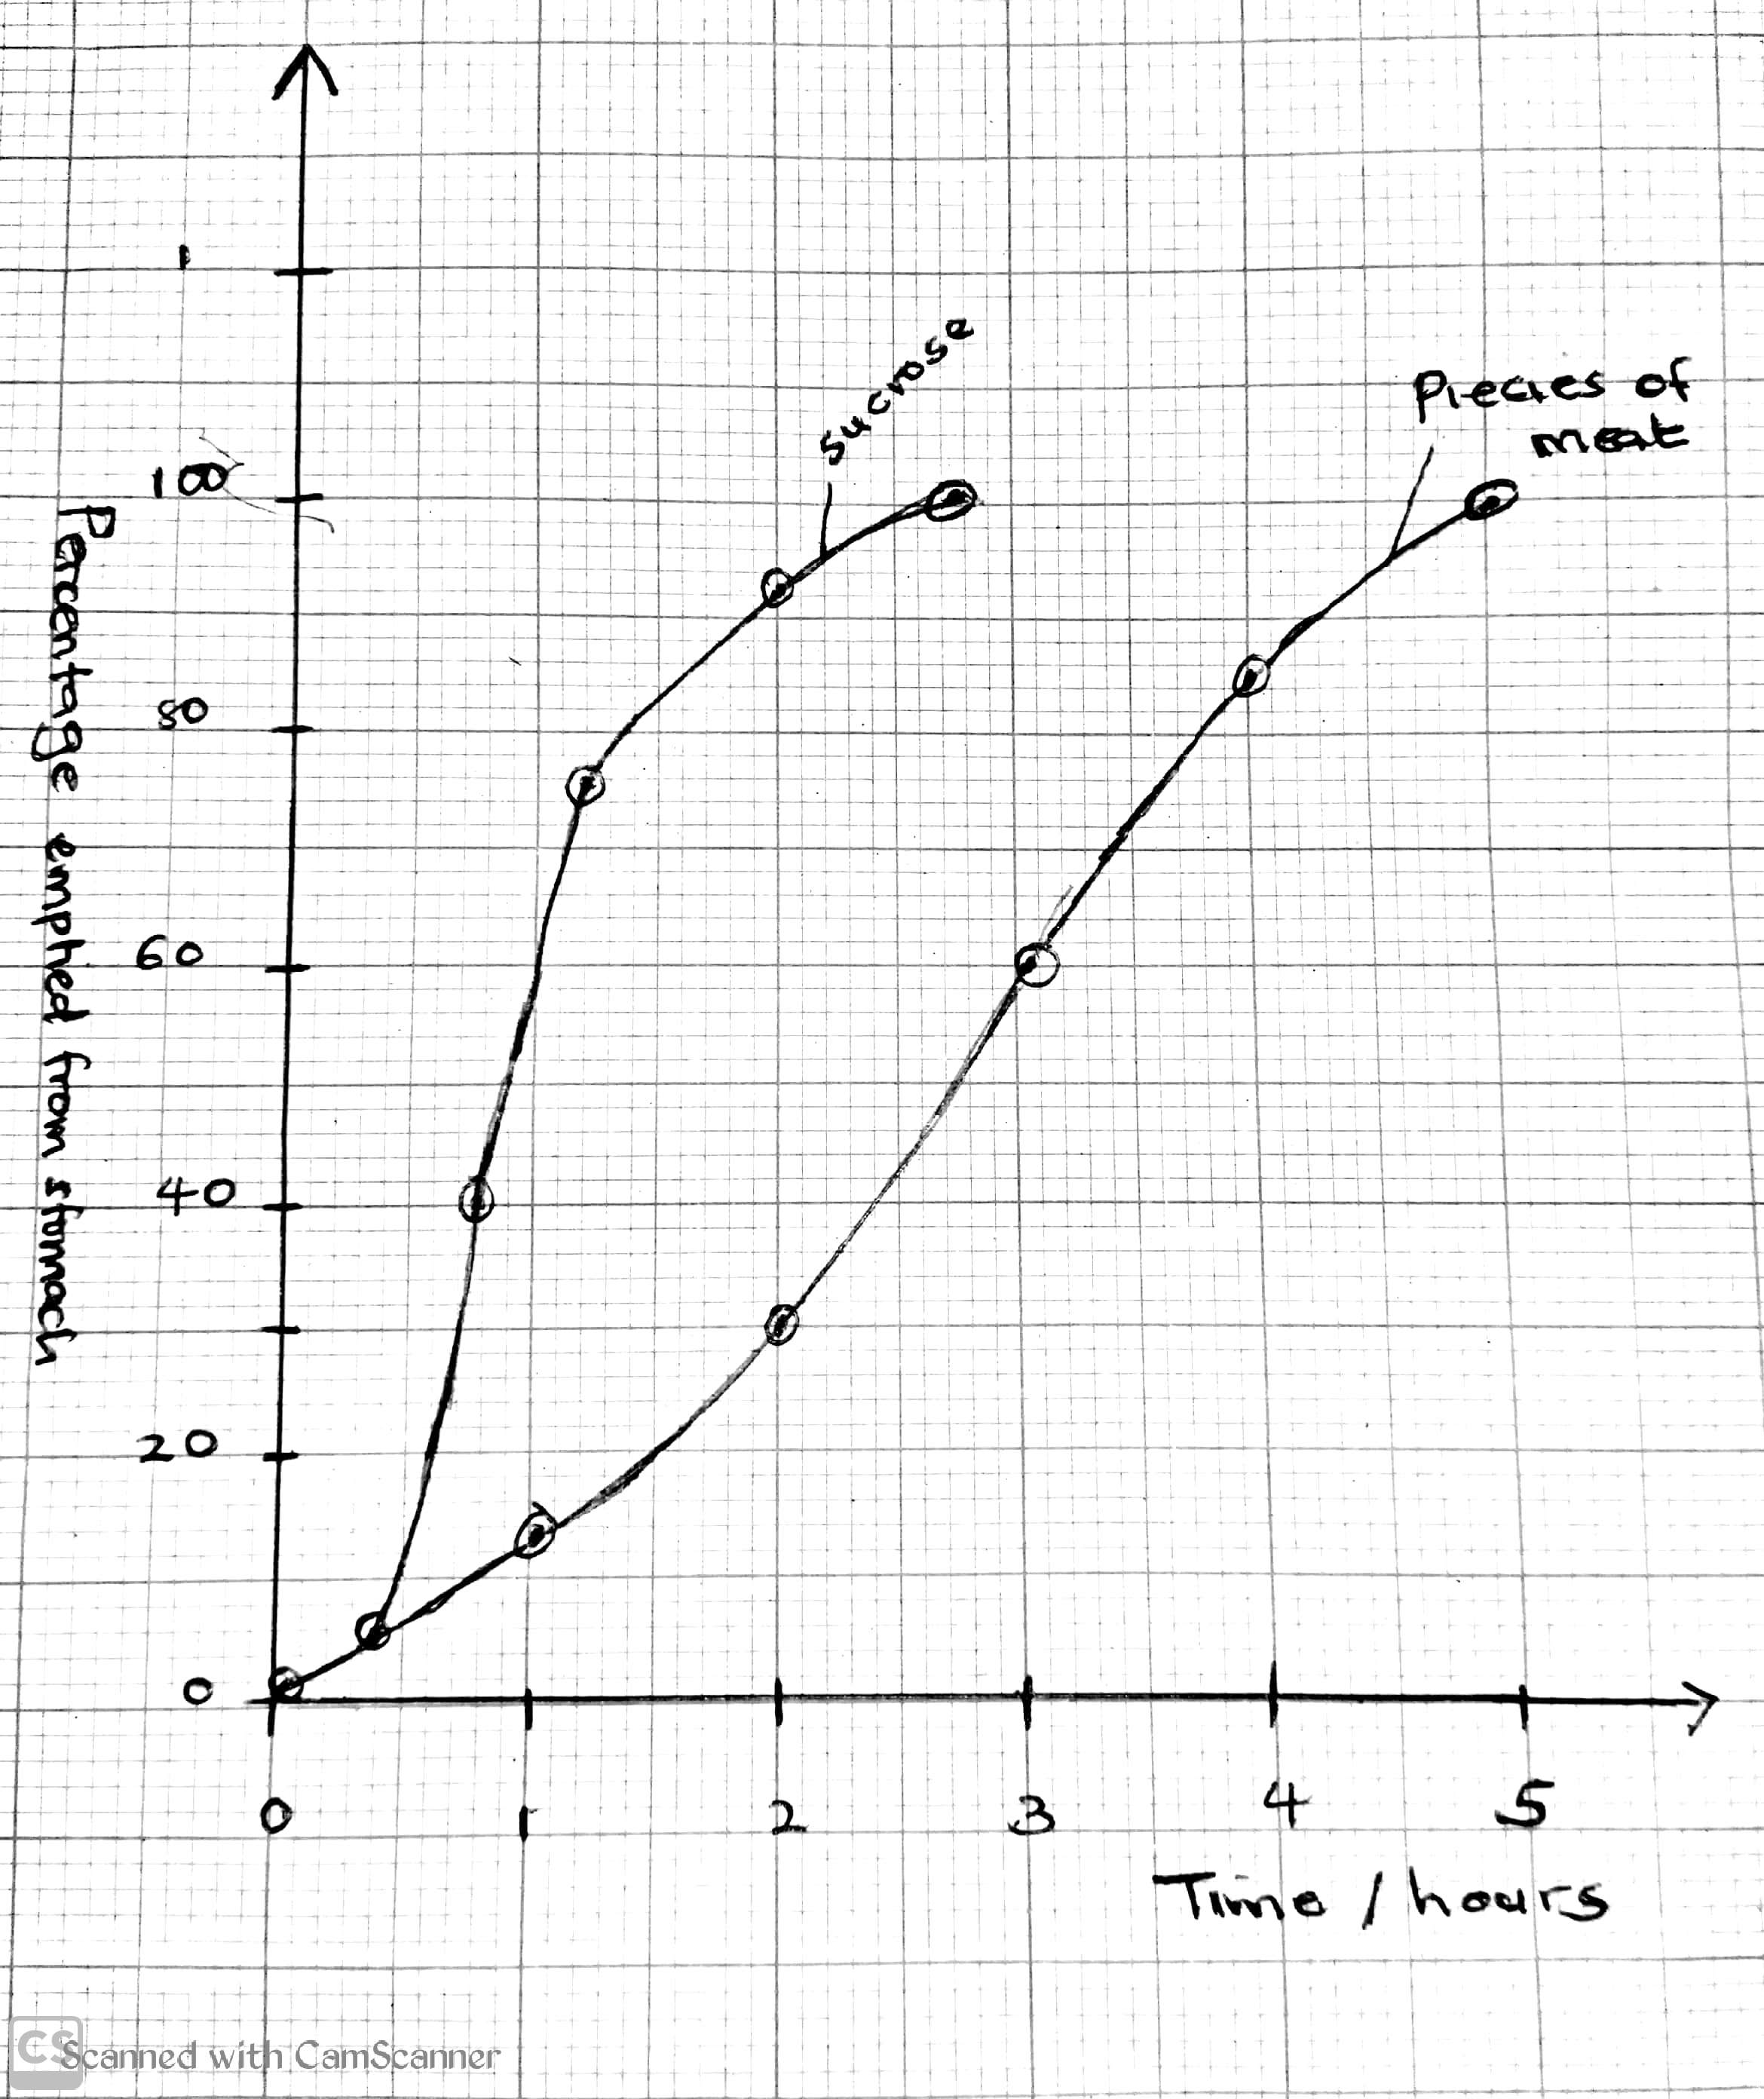

a) How long does it it take for 50%of each food to be emptied from the stomach
Sucrose solution
...............................................................................................................................
Pieces of meat
................................................................................................................................
b) state the difference in time taken for sucrose solution and pieces of meat to be emptied from the stomach
................................................................................................................................
................................................................................................................................
c) Explain for the difference stated in c(i) above. (06mrks)
................................................................................................................................
................................................................................................................................
................................................................................................................................
................................................................................................................................
................................................................................................................................
d) Describe the curve for sucrose solution(03mrks)
................................................................................................................................
................................................................................................................................
................................................................................................................................
e) Cells lining the stomach produce a Juice X that contains an enzyme pepsinogen which is an active form of pepsin
i) Identify juice X
...............................................................................................................................
................................................................................................................................
ii) Explain why pepsin is secreted in its inactive form
...............................................................................................................................
................................................................................................................................
iii) Describe the adaptations of the stomach to perform its functions.
...............................................................................................................................
................................................................................................................................
...............................................................................................................................
................................................................................................................................
2. The diagram below is an illustration to represent the human digestive system. Study it carefully and answer the questions that follow

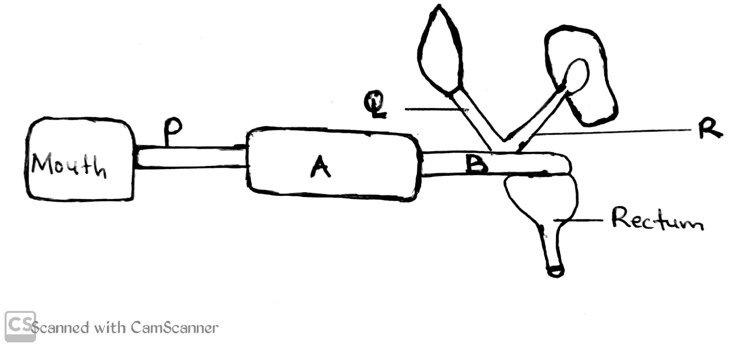

a) Identify
i) Chambers (02mrks)
A.........................................................................
B..........................................................................
ii) Structures (03mrks)
P..................................................................................
Q.................................................................................
R.................................................................................
b) state the functions of Q and R (02mrks)
Q............................................................................................
R............................................................................................
c) Explain what will when structure Q is blocked (03mrks)
................................................................................................................................
................................................................................................................................
................................................................................................................................
................................................................................................................................
3.a) Define assimilation(02mrks)
..............................................................................................................................
b) Give an example of mechanical digestion in the following parts of the alimentary canal (03mrks)
Part | Mechanical digestion
Mouth
Stomach
Duodenum
c) Trypsin is secreted in its inactive form called trypsinogen.
i) What substance activates trypsinogen to active trypsin (01mrk)
................................................................................................................................
................................................................................................................................
ii) State the region where pepsinogen is secreted from and the the food substance it works upon (02mrks)
Region
................................................................................................................................
................................................................................................................................
Food substance
................................................................................................................................
................................................................................................................................
d) Explain why a cow is able to obtain glucose from the cellulose. component of grass (02mrks)
................................................................................................................................
................................................................................................................................

Section C
4. Describe the structure of a villus
b) What are the adaptations of the villus to perform its function
5a). Describe the role of the following in digestion
i) liver
ii) Pancreas
iii) Salivary glands
b) State the adaptations of the herbivores for effective feeding on grass

